**EE390 Lab 2**

**Subject**: DAC with DMA Transfer

**Description:**

Write a program to generate a sine wave (output from PA4 pin). Divide a cycle of the sine wave into 60 points. Use DMA transfer to send the data to be converted to the DAC1. Use external trigger (TIM6) to trigger the DMA transfer every 4 s. The DMA must be configured to circular mode.

**Due:** **02/10/2023**

**Requirements**:

1. Write a program that implements the requirement (a) generate the sine waveform using DAC1 (b) use DMA function to transfer sine data to the DAC (c) configure TIM6 to trigger the DMA transfer (also trigger DAC conversion)
2. Submit a lab report that include the program flow description, the program list, and the discussion of this assignment.

Make sure you have the required B-L475E-IOT01A1 kit and component project kit (Arduino starter kit).

**Lab kit: B-L475E-IOT01A1** available from[**www.Digit-Key.com**](http://www.Digit-Key.com) **or** [**www.mouser.com**](http://www.mouser.com)

**Component Kit (**available from **Amazon.com) 🡪** One of the following Arduino project kits:

1. ELEGOO UNO Project Super Starter Kit **($36.99)a**

# ELEGOO Mega 2560 Project: The Most Complete Ultimate Starter Kit ($59.99)

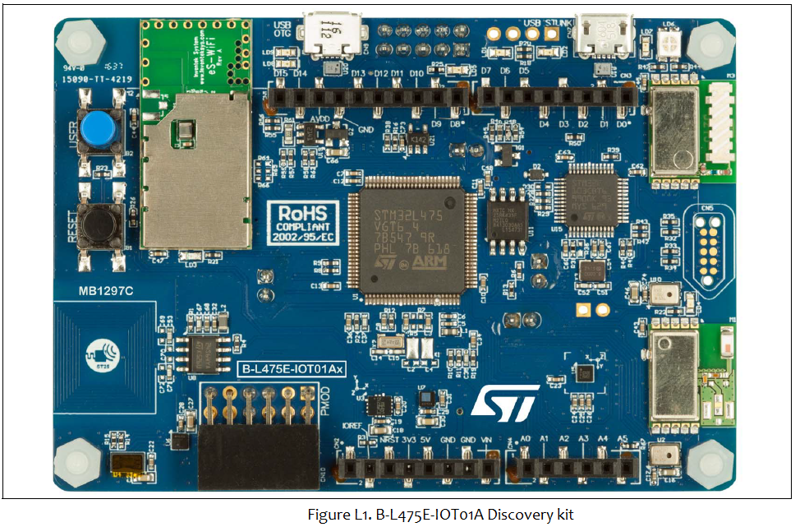

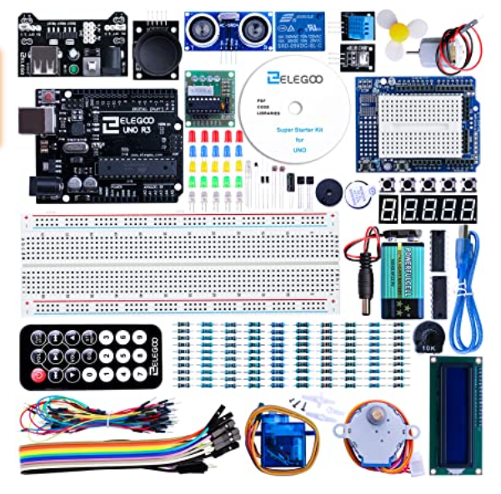

1. Elegoo Mega 2560 Arduino Starter kit

